CHAPTER 1
INTRODUCTION
  - SMART AGRICULTURE
Smart agriculture is an innovative attempt to change farming in India, the implementation of modern technology and data-driven approaches for optimizing and enhancing sustainability in crop production is referred to as "Smart Farming" or "Smart Agriculture". Smart agriculture mostly describes the use of internet of things (IOT) technologies in agricultural settings. IOT technology adoption in agriculture is growing quickly, because of supply chain disruptions and a manpower scarcity brought on by the covid-19 pandemic, the internet of things has grown even more rapidly in the agricultural sector. The IOT's compound annual growth rate (CAGR) in agriculture has increased to 9.9% as a result of this spike. The smart farming business is expected to grow to $6.2 billion by 2021, according to recent projections. Smart agricultural technology is a contemporary cultivation technique that optimizes farming practices using the latest technologies including automated processes, big data analytics, IOT, and artificial intelligence. Farmers may make informed decisions to increase crop yields, manage livestock better, and conserve resources by using internet of things (IOT) devices to collect real-time data on environmental conditions, soil health, and livestock status. Smart irrigation modifies water usage depending on weather and soil moisture information, while precision farming enables customized operations in particular field areas. To monitor the fields, crops, and cattle, it makes use of sensors, GPS tracking, Geo location, and drones. The core of every Internet of things technology is data. Smart farms need to establish a continuous and consistent cycle that gathers and evaluates data before executing the subsequent set of activities in order to guarantee optimization.
Illustration of a clever agricultural cycle:
- Sensors detect their environment and gather data on soil conditions, humidity, temperature, and other factors.
- Data analytics is performed on sensor-collected information by sending it to cloud-based IOT platforms.
- Farmers make pertinent judgments to provide higher-quality results depending on the study they have completed.
- It gathers precise volumes of precise data on the agricultural lands. Because decisions are made specifically for every kind of animal or plant rather than for every group of cattle or produce, plants and animals receive the precise quantity of nutrients they require.
- Smart agriculture minimizes its negative effects on the environment, maximizes the utilization of resources and reduces waste.
1.2 AIM OF THE PROJECT
Providing farmers with an effective and user-friendly instrument for continuous monitoring and evaluation of crop health and nutritional status directly in the field is the goal of the Internet of Things based portable soil nutrient analyser. This device aims at enabling data-driven choices for the purpose of optimizing crop management, enhancing agricultural output and promoting ethical farming methods. Giving farmers practical insights for increased crop yields and less environmental impact.
1.3 OBJECTIVE
The portable soil nutrient analyser with Internet of Things (IoT) base aims to give farmers a convenient tool for instantaneous soil testing. In the field, it measures important variables including temperature, pH, moisture content, and nutrient levels to help with informed soil management decisions. This encourages sustainable farming methods, increased food yields, and efficient resource usage.
Benefits of suggested IOT-based portable soil nutrient analyser:
- Real-time data: Offers up-to-date information on the condition of the field's soil and its nutrient levels.
- Precision agriculture: It enables the use of resources in a targeted manner by using particular soil data.
- Cost-effective: Minimizes the requirement for sample transportation and laboratory testing.
- Portability: Easy to utilize on various plots due to its compact and lightweight design.
- User-friendly: Provides farmers with an easy-to-use interface for accessing data and advice.
- Improved Productivity: Produces higher-quality and more abundant crops.
- Remote Monitoring: Sends information through an application for smartphones or cloud service for remote analysis and observation.
1.4 LITERATURE SURVEY
- IoT Based Smart Agricultural Monitoring System, Navjot Rathour, Sapna Singh, Rahul Purakayastha, This study provides a brief description about how to develop a smart farming system that integrates cutting-edge technology with conventional agricultural methods by utilizing the Internet of Things (IoT). Technology is developing at a rapid pace, especially in the area of the Internet of Things (IoT), which is changing agriculture and bringing new techniques for controlling and observing agricultural operations. Smart agricultural monitoring systems that are based on the Internet of Things (IoT) have become a novel way to improve farming operations' sustainability and efficiency. In order to gather data in real-time on a range of agricultural and environmental parameters, including soil moisture, temperature, humidity, nutrient levels, and weather, these systems combine Internet of Things sensors and devices. The information is wirelessly transferred to a cloud-based platform or centralized platform for analysis and data-driven decision-making. This field of study focuses on the application of various sensor types, such as those for crop health, livestock welfare, and soil condition monitoring. For example sensors measuring soil moisture aid in determining the best times to water, and sensors measuring temperature and humidity shed light on the microclimate of growing regions. Early disease and pest detection through crop health monitoring enables prompt intervention.
Precision agriculture is one application of IoT-based technology in agriculture that customizes farming methods to certain field zones. Overall, the literature highlights the significant impact of IoT in modern agriculture and the importance of continued research and development in this field to address current challenges and unlock further benefits.

- Application of Internet of Things (IoT) in Agriculture: A Review,
M. Zamir, R. Sonar, This paper describes a major change in contemporary farming methods is represented by the use of the Internet of Things (IoT) in agriculture, which makes it possible to gather and analyze data in real-time to maximize productivity, sustainability, and resource management. By utilizing the Internet of Things, precision agriculture may customize agricultural practices like fertilization and irrigation to target field zones, increasing productivity and yields. IoT devices also make agricultural monitoring easier, enabling the early identification of problems like pest infestations or nutrient shortages. Wearable technology tracks the health and activity of animals in livestock management to provide preventative treatment. Water resources are preserved via smart irrigation systems that automate watering schedules depending on soil moisture and meteorological data. Furthermore, by guaranteeing product quality and safety through end-to-end traceability, IoT enhances supply chain management and post-harvest processes. Farmers can oversee operations from a distance thanks to remote monitoring and control.

- A Smart and Secure Agricultural System Using IoT, Shaik Mohd Abubakar, Shakeel Ahmed, The literature on Internet of Things-based smart and secure agricultural systems shows how incorporating connected devices and sensors into farming methods can have revolutionary effects. Farmers may make data-driven decisions that improve crop yields and resource efficiency by using IoT technologies to provide real-time monitoring of environmental and operational elements including temperature, humidity, soil moisture, and crop health. In order to secure crops and equipment, these systems also come equipped with sophisticated security features like sensors and cameras that can detect unlawful entry or intruders. Farmers are able to oversee and manage their farms remotely with mobile applications, which enhances responsiveness and efficiency. Although obstacles like data security, privacy, and interoperability still exist, continued research is tackling these problems to help IoT become more widely used.
- Low-cost IoT-Based Smart Notification System for Rural Agriculture, Muhammad Umar Diginsa, Y. Md Yuso, This study explains the research on inexpensive IoT-based smart notification systems for rural agriculture shows that these systems have the potential to improve conventional farming methods by giving farmers access to real-time data and insights at a reasonable cost. These systems monitor important agricultural characteristics including soil moisture, temperature, and crop health by using readily available sensors and networking choices. These solutions facilitate fast reactions to emergent difficulties by sending instant notifications to farmers' mobile devices. By reducing waste, this real-time monitoring promotes sustainable farming and maximizes the use of available resources. Furthermore, low-cost IoT systems can use other wireless technologies, such as low-power wide-area networks (LPWAN), to get around connectivity issues in remote places. All things considered, inexpensive IoT-based smart notification systems present a viable strategy for raising sustainability and productivity in rural agriculture.

- IoT Based Real Time Soil Nutrients Detection, Varsha Kiran Patil, Aniket Jadhav, Someshwar Gavhane, Venkatesh Kapare, This literature indicates that such systems have the potential to revolutionize traditional soil testing methods, which are often time-consuming and require sending samples to laboratories for analysis. These sensors collect real-time data on soil conditions, allowing farmers to understand the nutrient status of their soil and make informed decisions about fertilization and soil management. IoT-based systems offer immediate, in-field testing and analysis, providing farmers with instant feedback on soil health. This allows for precise adjustments in nutrient application, optimizing fertilizer use and minimizing environmental impact. Moreover, the data collected by IoT sensors can be transmitted wirelessly to a central platform or cloud storage, where it can be analysed and visualized for easier interpretation. Farmers can access this data through mobile applications or other interfaces, enabling them to track changes in soil nutrient levels over time and respond accordingly. Overall, the research emphasizes the significant benefits of IoT-based real-time soil nutrient detection, including enhanced productivity, reduced costs, and improved environmental sustainability.

CHAPTER 2
EXISTING SYSTEM
2.1 EXISTING METHODOLOGY
There are several existing systems and methods for soil nutrient analysis that farmers and agronomists use today. These systems vary in complexity and cost and can range from traditional laboratory testing to modern in-field testing using advanced sensor technologies. Here is an overview of the existing systems for soil nutrient analysis:
Testing of Soils in a Laboratory:
- Sample Gathering: A variety of fields are used to get soil samples.
- Laboratory study: The samples are sent to a laboratory for in-depth study. There, pH, organic matter content, nutrient levels (such as nitrogen, phosphorous, and potassium) and other soil properties are measured using chemical techniques.
- Findings and Suggestions: By addressing the findings and implementing the suggested recommendations, farmers can aim to optimize crop productivity, enhance soil health, and mitigate weather-related risks, ultimately ensuring the sustainability and profitability of your farm operations.

Kits for Testing Soils:
- Chemical Test Kits: With the use of these kits, soil samples can be tested on location for nutrients, pH, and other characteristics using chemical reagents and colorimetric techniques.
- Accuracy: Although these kits yield rapid answers, adequate calibration is crucial because their accuracy can differ from that of laboratory testing.
Both methods have advantages and disadvantages inspite traditional laboratory soil testing can be time-consuming because samples must be collected, transported to a lab and farmers can't use the information immediately to make decisions on the spot and Laboratory testing can be costly. In testing kit, some testing kits are single-use or have limited lifespan, requiring regular replacement, which can add to costs. Testing kits usually do not provide options for data storage or analysis, limiting long-term tracking of soil health over time.
2.2 DISADVANTAGES OF EXISTING METHODOLOGY
- Time Lag: Decisions that must be made in the field may be delayed by the time it takes to gather samples, send them to the lab, and wait for results.
- Cost: The cost of laboratory testing can be high, especially if more or specialist testing is required.
- Logistical Difficulties: Gathering samples and transporting them to a laboratory might provide logistical difficulties, particularly for farmers in isolated regions.
- Absence of Real-Time Feedback: Adjustments depending on soil conditions cannot be made in real-time because results take time to come in.
- Lack of Integration: Some systems are not integrated with other instruments for agricultural management, which might make it difficult to make comprehensive decisions.
- Labor-Intensive: Traditional soil nutrient monitoring methods often require extensive labor, including soil sampling, laboratory analysis, and data interpretation. This can be time-consuming and costly for farmers, especially for large-scale operations.
- Invasive Sampling: Traditional soil sampling methods often involve physically extracting soil cores from the ground, which can disrupt soil structure and affect soil health. Frequent sampling may lead to compaction and degradation of soil quality over time.
By addressing these disadvantages by exploring alternative soil nutrient monitoring technologies, such as remote sensing, precision agriculture techniques, and sensor-based systems, can offer opportunities for more efficient, cost-effective, and sustainable soil management practices.
CHAPTER 3
PROPOSED SYSTEM
3.1 PROPOSED METHODOLOGY
This chapter discusses the project components that were used. The components utilised in the project’s operation, specification and function are also briefly described in this part.
3.2 PROPOSED SYSTEM
Our suggested setup is an advanced tool for measuring and analysing the amounts of nutrients (nitrogen, phosphorus, and potassium) in soil. This system represents a soil analyser with an NPK sensor. Farmers, researchers, and gardeners can make educated decisions about crop management, fertilization, and soil health. The main parts of our suggested system is to analysis system and to collaborate to collect and show soil nutrient data instantly. The NPK sensor (JXBS-3001) is a key component since it uses electrodes or other sensing devices to determine the amounts of potassium, phosphorus and nitrogen in the soil. Farmers and agronomists can properly measure the health of their soil. The data collection from the sensor is handled by the Arduino or another microcontroller, which also processes the readings to understand the nutrient levels. Farmers may quickly obtain information on soil health. Quick testing at several places is made possible by this adaptable and user-friendly system, which offers thorough and effective soil assessments right on the farm.
3.3 IMPACT OF IOT IN SOIL MANAGEMENT SYSTEMS
Agriculture has undergone a radical change as a result of the incorporation of Internet of Things (IoT) technology into soil management systems. Farmers can now track important data in real-time, including temperature, pH, nutrient content, and moisture levels, thanks to IoT-enabled sensors buried in the soil. With the use of this real-time data, farmers are better able to manage their crops and use resources more efficiently by making timely decisions about fertilization, irrigation, and crop management techniques. IoT technology also makes precision agriculture possible by allowing for the precise application of inputs like water, fertilizer, and pesticides based on soil conditions, which reduces waste and its negative effects on the environment. In addition to powering sophisticated analytics and machine learning algorithms, the data produced by IoT sensors gives farmers important insights into the dynamics of soil health and facilitates predictive analysis for improved decision-making. Furthermore, remote monitoring features boost production and efficiency by enabling farmers to oversee agricultural activities and soil health from any location. Internet of Things-enabled soil management systems support sustainable agricultural practices by identifying early indicators of soil-related problems and facilitating proactive remedies. IoT soil monitoring data, when integrated with other farm management systems, enables comprehensive farm management, optimizing activities for optimal profitability and efficiency.
3.4 BLOCK DIAGRAM OF PROPOSED SYSTEM
The proposed block diagram of “IOT BASED PORTABLE SOIL NUTRIENT ANALYZER” is shown below

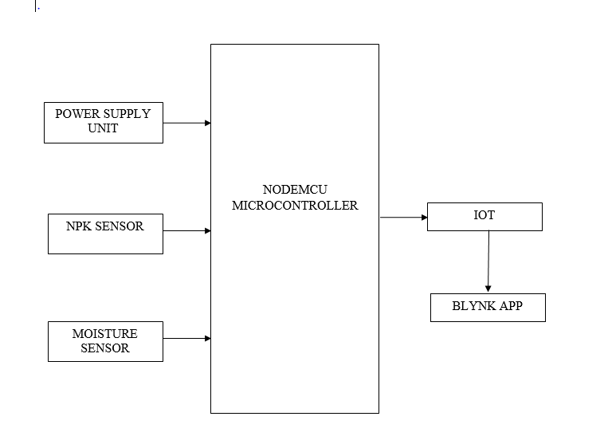

Figure 3.2 Block Diagram Representation of Proposed System

3.4.1 BLOCK DIAGRAM EXPLAINATION
The proposed system is controlled by the Node MCU .This system
Consists of a NPK Sensor, Soil Moisture Sensor, ESP8266 – Node MCU, and Power Supply Unit. The results of the system are seen in the BLYNK Iot app. The NPK sensor checks for the Nutrients level in the soil and the soil moisture sensor checks for the moisture level in the soil and micro- controller Which acts as the total controller.
    - WORKING
- This project works like a portable device, which can be controlled using a micro controller and the output is shown through an app called Blynk IoT.
- This NPK sensor find out how much nitrogen, phosphorus, and potassium are present in the soil.
- This Moister sensor is used to determine the moisture level present in the soil.
- Once these sensor detects the necessary information it communicate the data through internet of things to an user interface called BLYNK Iot app.
- Blynk works over the Internet, so it will need an Ethernet or Wi-Fi Shield to communicate for this we are using ESP8266 it is already internet enabled device.
- This Suggested setup display the nutrient levels that helps the farmers, researchers to take the decision instantly about the crop health, crop yield etc.
CHAPTER 4
HARDWARE DESCRIPTION
4.1 HARDWARE
Hardware used in this project are
- ESP8266 – Node MCU
- NPK Sensor
- Soil moisture sensor
- Power supply Unit (AC/DC)
4.1.1 ESP8266EX WIFI MODULE
ESP8266EX offers a complete and self-contained WiFi networking solution; it can be used to host the application or to offload WiFi networking functions from another application processor. When ESP8266EX hosts the application, it boots up directly from an external flash. In has integrated cache to improve the performance of the system in such applications. Alternately, serving as a WiFi adapter, wireless internet access can be added to any micro controller- based design with simple connectivity (SPI/SDIO or I2C/UART interface).
Espressif ESP8266 Serial ESP-01 WiFi Module offers a user-friendly WiFi SoC (system on a chip) solution to meet the continuous demands for a power-friendly, compact and reliable solution to a vast range of issues in the IoT Industry. The Espressif ESP8266 Serial ESP-01 WiFi Module is integrated with TCP/IP protocol stack that can give any MCU access to your home, work, or industrial WiFi network.
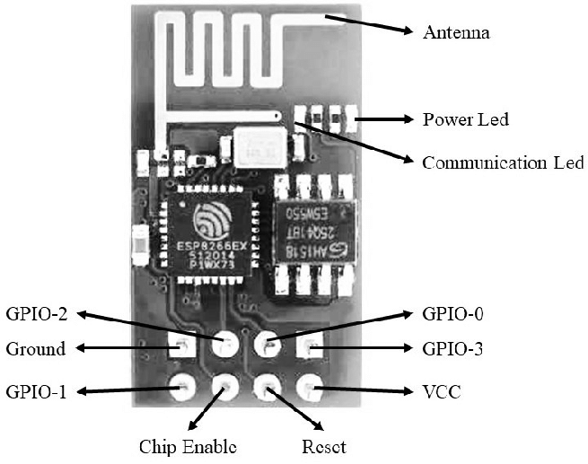
Figure 4.1.1 ESP8266EX WIFI MODULE
ESP8266EX is among the most integrated WiFi chip in the industry; it integrates the antenna switches, RF balun, power amplifier, low noise receive amplifier, filters, power management modules, it requires minimal external circuitry, and the entire solution, including front-end module, is designed to occupy minimal PCB area.
The module can perform either as a standalone application or as a slave to a host MCU. Espressif ESP8266 Serial ESP-01 WiFi Module can be applied to any MCU design as a Wi-Fi adaptor through SPI/SDIO or UART interfaces. The ESP8266 WIFI module also features an upgraded version of Ten silica’s L106 Diamond series 32-bit processor and SoC SRAM, allowing easy interfacing with external sensors and other devices through the GPIOs.

4.1.2 NPK SENSOR
The soil nitrogen, phosphorus and potassium sensor has stable performance and high sensitivity. It can judge the fertility of the soil by detecting the content of nitrogen, phosphorus and potassium in the soil to evaluate the soil condition. It is suitable for soil moisture monitoring, scientific experiments, agricultural irrigation, greenhouses, flowers and vegetables, etc. Grassland pasture, soil quick test, plant cultivation and other occasions. Appropriate nitrogen, phosphorus and potassium content is an important condition for plant growth.
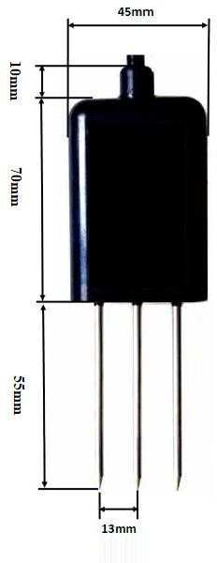
Figure 4.1.2 NPK SENSOR
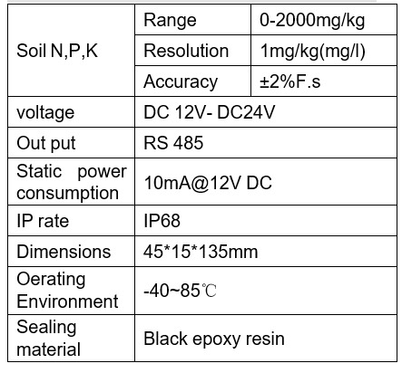
Table 4.1.2 Parameter of NPK Sensor
4.1.3 SOIL MOISTURE SENSOR
To determine the amount of moisture in the soil, soil moisture sensors are frequently employed in smart agriculture and other garden automation projects. It has four pins total, with two of them -Vcc and Gnd connected to the supply voltage. The output pins are analog (A0) and digital (D0) on the two remaining pins. The output of the digital pin (D0), which is either logic 0 or logic 1, will decrease when the moisture content of the soil rises above the threshold level. The inbuilt potentiometer can be adjusted to change the sensor module's threshold value. The estimated amount of moisture content in the soil can be determined using the analog output pin. The two probes that make up the soil moisture sensor are used to determine the volumetric content of water. In order to assess the moisture content, the two probes let current flow through the soil and then obtain the resistance value. There will be less resistance when there is more water since the soil will conduct more electricity. As a result, there will be more moisture present. Since dry soil doesn't conduct electricity well, less water will cause the soil to conduct less electricity, increasing resistance. As a result, there will be less moisture. Specifications for Soil Sensors include Voltage difference (VDC) is 3.3 to 5 V for PCB. The dimensions are about 1.5 cm by 3 cm and measurements of the soil probe is around 6 cm by 3 cm and length of cable is 20 cm.
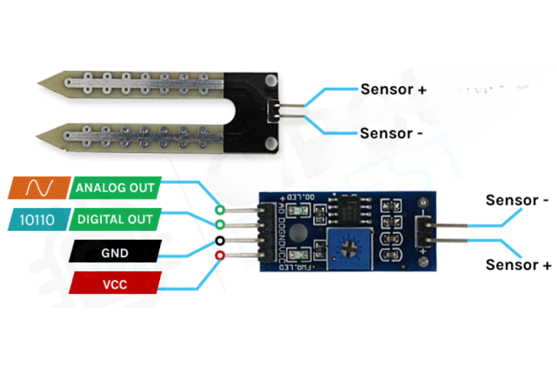
Figure 4.1.3 Soil moister sensor

4.1.4 POWER SUPPLY
The ac voltage, typically 220V rms, is connected to a transformer, which steps that ac voltage down to the level of the desired dc output. A diode rectifier then provides a full-wave rectified voltage that is initially filtered by a simple capacitor filter to produce a dc voltage. This resulting dc voltage usually has some ripple or ac voltage variation. A regulator circuit removes the ripples and also remains the same dc value even if the input dc voltage varies. This voltage regulation is usually obtained using one of the popular voltage regulator IC units.

Figure 4.1.4 Block diagram representation of power supply

CHAPTER 5
SOFTWARE DESCRIPTION
5.1 BLYNK APP WORKING:
Blynk was designed for the Internet of Things. It can control hardware remotely, it can display sensor data, it can store data, vizualize it and do many other cool things. There are three major components in the platform:
Blynk App – It allows to you create amazing interfaces for your projects using various widgets we provide.
Blynk Server – It responsible for all the communications between the smartphone and hardware. You can use our Blynk Cloud or run your private Blynk server locally. Its open-source, could easily handle thousands of devices and can even be launched on a Raspberry Pi.
Blynk Libraries – It is used for all the popular hardware platforms - enable communication with the server and process all the incoming and outcoming commands.
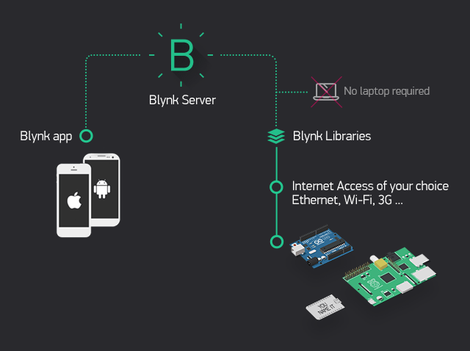
Figure 5.1 Showing BLYNK App Working
CHAPTER 6
HARDWARE SETUP
6.1 HARDWARE SETUP OF SUGGESTED SYSTEM
The hardware set up of this project is shown figure,

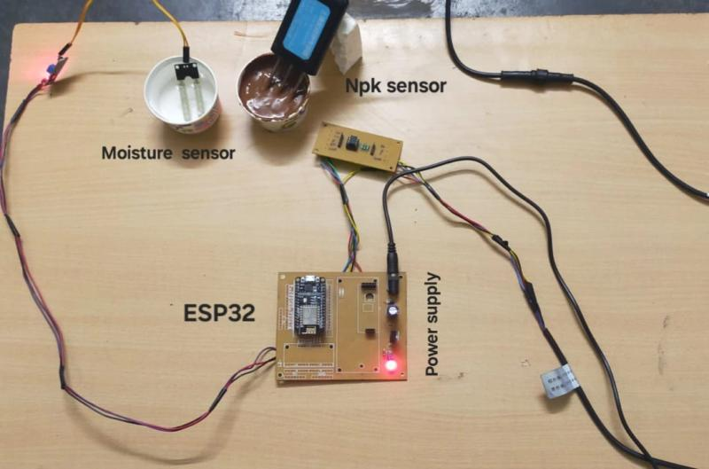

CHAPTER 7
RESULT AND OBSERVATION
7.1 OPERATION
Once the kit gets ON, it searches for a wifi protocol according to the feeded data and gets paired with the device, now the sensor determine the nutrient level and the moisture level in the soil and this Suggested setup display the nutrient levels and moisture level present in the soil.

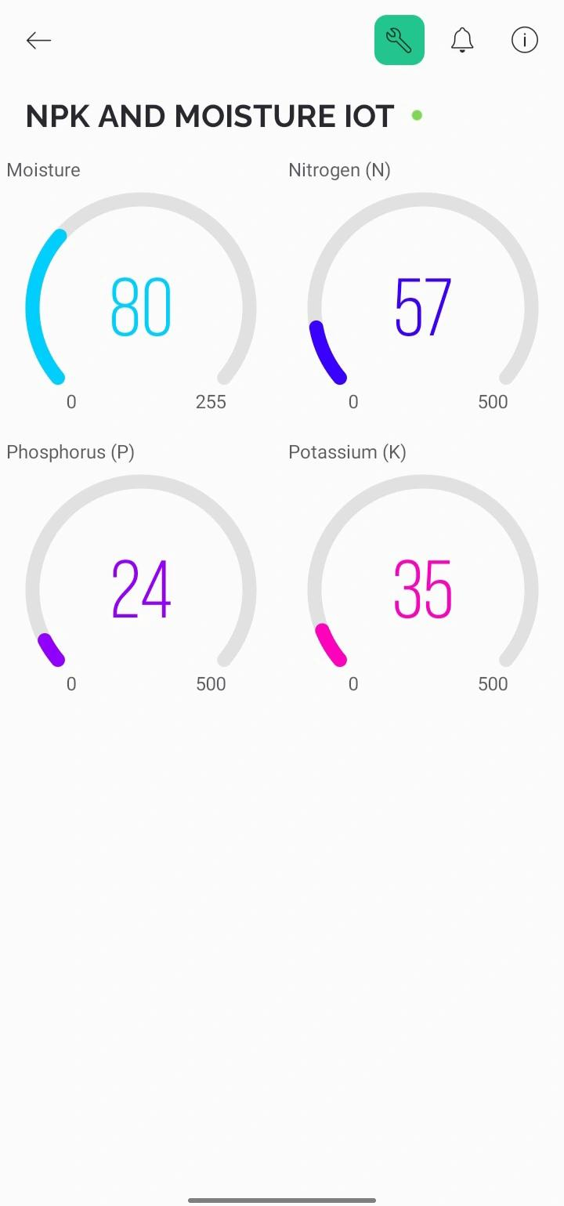

7.2 Rating Chart for Soil Test Data

7.2 Rating Chart for Soil Test Data
These charts typically encompass a range of parameters, including nutrient levels such as nitrogen (N), phosphorus (P), potassium (K), calcium (Ca), magnesium (Mg), and others. They categorize these nutrient levels into low, medium and high offering insights into whether additional fertilization is required and in what quantities. By comparing these rating chat with the suggested system output, we can able to determine the accuracy of the suggested system. This system facilitates informed decision making by providing clear interpretations of soil test results, empowering farmers, gardeners and land managers to make optimal choices regarding soil management practices. The chart helps in optimizing nutrient management by categorizing nutrient levels and offering recommendations, ensuring crops receive the right amount of nutrients while minimizing waste and environmental impact. It provides guidance on adjusting nutrient level to create ideal growing conditions for specific plants, thus enhancing crop productivity.

CHAPTER 8
CONCLUSION AND FUTURE SCOPE
8.1 CONCLUSION
The IoT-based portable soil nutrient analyzer offers a modern, efficient, and accurate method for assessing soil health by measuring essential nutrients such as potassium, phosphorus, and nitrogen. Better crop yields and more sustainable agriculture practices result from farmers and gardeners using its real-time data collecting and remote monitoring capabilities to make educated decisions about managing their soil and maximizing the usage of fertilizers. Because of its mobility and simplicity of use, the system is a useful tool for on-the-spot testing in a variety of settings, offering insightful information for preserving healthy soils. This data-driven approach allows users to tailor soil management practices precisely, optimizing the application of fertilizers and soil amendments to promote healthier crops and sustainable agriculture. The system's ability to remotely monitor soil conditions also enables users to make informed decisions from a distance, enhancing productivity and resource efficiency. With the introduction of the portable, Internet of Things-based soil nutrient analyzer, agriculture is about to undergo a significant revolution. This cutting-edge technology opens up an enormous number of possibilities for future growth and integration in addition to giving farmers real-time insights into the health of their soil and nutrient levels. Improvements in sensor capabilities may allow for the inclusion of more characteristics, such as pH, organic matter content, and moisture levels, in a thorough investigation of soil health. The ability to store and analyze data centrally through cloud connectivity makes it easier for researchers, agronomists and farmers to work together.

CHAPTER 9
REFERENCES
- “Design and implementation soil analyser using IoT”, Prachi Sharma, D.V. Padole, International Conference on Innovations in Information, Embedded and Communication Systems (ICIIECS), 2017
- “Low-cost IoT-Based Smart Notification System for Rural Agriculture”, Muhammad Umar Diginsa Y. Md Yusof, M. Z. Adam, Open international journal of informatics, 2023
- “IoT Based Smart Agricultural Monitoring System”, Navjot Rathour, Sapna Singh, Avinash, Suyash Ralhan, Rahul Purakayastha, 2023 2nd International Conference on Edge Computing and Application, 2023
- “Smart agriculture monitoring system using IoT”,P. Lashitha, Vishnu Priya, Dr. N. V. K. Ramesh, International journal of engineering and technology, 2018
- “IOT based Smart Agriculture Monitoring and Irrigation System”, M. SwarajC, K. Sowmyashree, International journal of engineering research and technology, 2020
- “IoT Based Agricultural Robot for Monitoring Plant Health and Environment Plant Health”, Gurucharan, S. Professor, Journal of emerging technologies and innovative research, 2019
- “Internet of Things Applications for Agriculture”, Q. F. Hassan, Agricultural and Food Sciences, Computer Science, Engineering, 2018
- “IoT Based Smart Farm Monitoring System”, R. Mythili, M. Kumari, N. Pal
- Published in International journal of recent technology and engineering, 30 November 2019
- “Iot Based Environmental Weather Monitoring and Farm Information Tracking System”, R. ArunChakravarthy, M. Bhuvaneswari, M. Arun, Published in 2020
- “Role of IoT in agriculture”, Veerpal Kaur, R. Kaur, Published in Journal of Pharmacognosy and Phytochemistry, 2019
- “IoT Applications in Agriculture: A Systematic Literature Review”, Raquel Gomez-Chabla, Karina Real-Aviles, C. Morán, Paola E. Grijalva, T. Recalde, Published in ICT for Agriculture and Environment, 27 December 2018

